To improve that capacity consumption problem, you could follow the below recommendations:

1. Increase the Query Memory Limit to a 60 and see how it behaves, if it didn’t improve the performance, please check the below points.

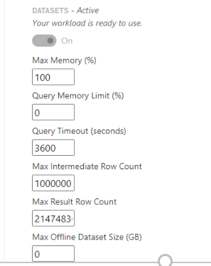

1. Upgrade to a tier with more available memory. As you can see below the P1 you have, it has a limit of 25 GB of memory which is being exceeded in some of the cases.

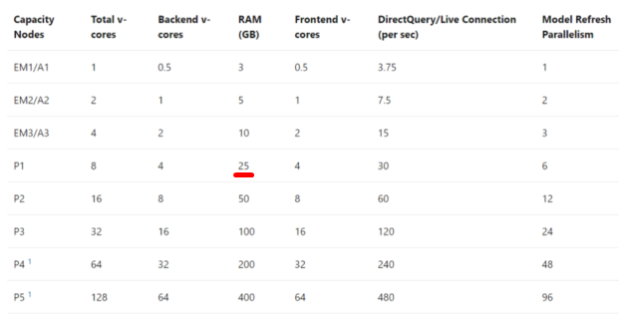

1. Use  Gen2 as  there is no memory Limit for the capacity as a whole, however please feel free to check first the documentation and limitations.  [https://docs.microsoft.com/en-us/power-bi/admin/service-premium-what-is#power-bi-premium-generation-2-preview](https://nam11.safelinks.protection.outlook.com/?url=https%3A%2F%2Fdocs.microsoft.com%2Fen-us%2Fpower-bi%2Fadmin%2Fservice-premium-what-is%23power-bi-premium-generation-2-preview&data=04%7C01%7Cbsittig%40good-sam.com%7C53e61dbd5e3e44c1601108d906a3999e%7C02a24813640d46cdb583949f041372b0%7C1%7C0%7C637548121991302080%7CUnknown%7CTWFpbGZsb3d8eyJWIjoiMC4wLjAwMDAiLCJQIjoiV2luMzIiLCJBTiI6Ik1haWwiLCJXVCI6Mn0%3D%7C1000&sdata=sqnztnKKdZ%2F3YIDRevcQqfR49R%2B4JjbBQnfNzxskPBg%3D&reserved=0)
2. Optimize your datasets.
3. Reschedule or distribute the time of the data refresh in case you execute more than 6 at the same time (Maximum of 6 refreshes at the same time for a P1). Please take into consideration the optimization of the datasets.

Please let me know your comments and how would you like to proceed with the case.